EASTERN INTERNATIONAL UNIVERSITY | Practice Assignment – Quarter 4, 2025- 2026
SCHOOL OF COMPUTING  AND INFORMATION TECHNOLOGY | Course Name: ISAD  Course Code: CSW 309
Student’s Full Name: Vũ Đức Tùng
Student ID: 2331200132

LAB 07
UML Modeling and UI/UX Wireframe Design

Assignment Objective
The objective of this assignment is to help students analyze an ATM Self-Service Banking System and design UML diagrams and a basic UI/UX wireframe based on the given scenario.
After completing this assignment, students should be able to:
- Identify functional requirements from a real-world system scenario.
- Draw UML diagrams including Use Case, Activity, Class, State, and Sequence Diagrams.
- Apply include and extend relationships in a Use Case Diagram.
- Design a basic UI/UX wireframe with controls, validation, and message feedback.
- Use draw.io to create diagrams and export the final work as a PDF file.

Scenario: ATM Self-Service Banking System
A bank wants to improve its ATM system to support secure self-service banking transactions. The ATM allows one customer to use the machine at a time.
To start a session, the customer inserts an ATM card. The ATM reads the card information and sends it to the Bank System for validation. If the card is valid, the ATM asks the customer to enter a PIN. The Bank System validates the PIN. If the PIN is correct, the ATM displays the main menu.
The customer can choose one or more transactions during the same session, including cash withdrawal, balance inquiry, PIN change, and mini statement printing. After each transaction, the ATM asks whether the customer wants to perform another transaction. If the customer selects Yes, the system returns to the main menu. If the customer selects No, the ATM returns the card and ends the session.
For cash withdrawal, the customer selects an account type, such as Savings or Current Account, and enters a withdrawal amount. The system checks whether the amount is valid, whether the selected account has enough balance, and whether the ATM has enough cash. If all conditions are satisfied, the ATM dispenses cash, updates the account balance, saves the transaction record, and asks whether the customer wants to print a receipt.
For PIN change, the customer enters the old PIN, new PIN, and confirms the new PIN. The system validates the old PIN and checks the new PIN format. The new PIN must contain 4 to 6 numeric digits and must match the confirmed PIN. If valid, the system updates the PIN.
The system must handle important exception cases. If the card is invalid, expired, or blocked, the ATM displays an error message and returns the card. If the PIN is incorrect, the customer can try again. After three incorrect PIN attempts, the ATM retains the card and ends the session. If the withdrawal amount is invalid, the balance is insufficient, or the ATM does not have enough cash, the system displays an error message and cancels the withdrawal. If the PIN confirmation does not match, the ATM asks the customer to enter the new PIN again. The customer may cancel a transaction before it is completed.
Maintenance staff can check ATM status, view cash level, refill cash, and change the ATM status to Available or Out of Service.
Successful transactions are saved as transaction records. Both successful and failed transaction attempts must be recorded in the audit log for security and audit purposes.

Assignment Requirements
Students must use draw.io to complete the following tasks.

Part A. Identify Functional Requirements
Identify the main functional requirements of the ATM Self-Service Banking System based on the scenario.
1. Authentication & Session Management
- The system must read the inserted ATM card information and send it to the Bank System for validation.
- If the card is valid, the system must ask the customer to enter a PIN and validate it with the Bank System.
- The system must display the main menu once the PIN is successfully validated.
- The system must allow the customer to perform one or more transactions during the same session by asking if they want to perform another transaction after each completion.
- If the customer selects "No" for another transaction, the system must return the card and end the session.
2. Customer Transactions
- Cash Withdrawal: The system must allow the customer to select an account type (Savings or Current Account) and enter a withdrawal amount. The system must verify if the amount is valid, if the account has enough balance, and if the ATM has enough cash. If all conditions are satisfied, it must dispense cash, update the account balance, save the transaction record, and ask if the customer wants a receipt.
- PIN Change: The system must require the customer to enter the old PIN, a new PIN, and confirm the new PIN. It must validate the old PIN, check that the new PIN format contains 4 to 6 numeric digits, and ensure it matches the confirmed PIN before updating.
- Other Transactions: The system must support balance inquiry and mini statement printing.
- The system must allow the customer to cancel a transaction before it is completed.
3. Maintenance Staff Functions
- The system must allow maintenance staff to check the ATM status and view the cash level.
- The system must allow maintenance staff to refill cash.
- The system must allow maintenance staff to change the ATM status to "Available" or "Out of Service".

Part B. Use Case Diagram
Draw one Use Case Diagram for the ATM system.
The diagram must include:
- Actors and system boundary
- Main use cases for Customer and Maintenance Staff
- At least two include relationships
- At least two extend relationships

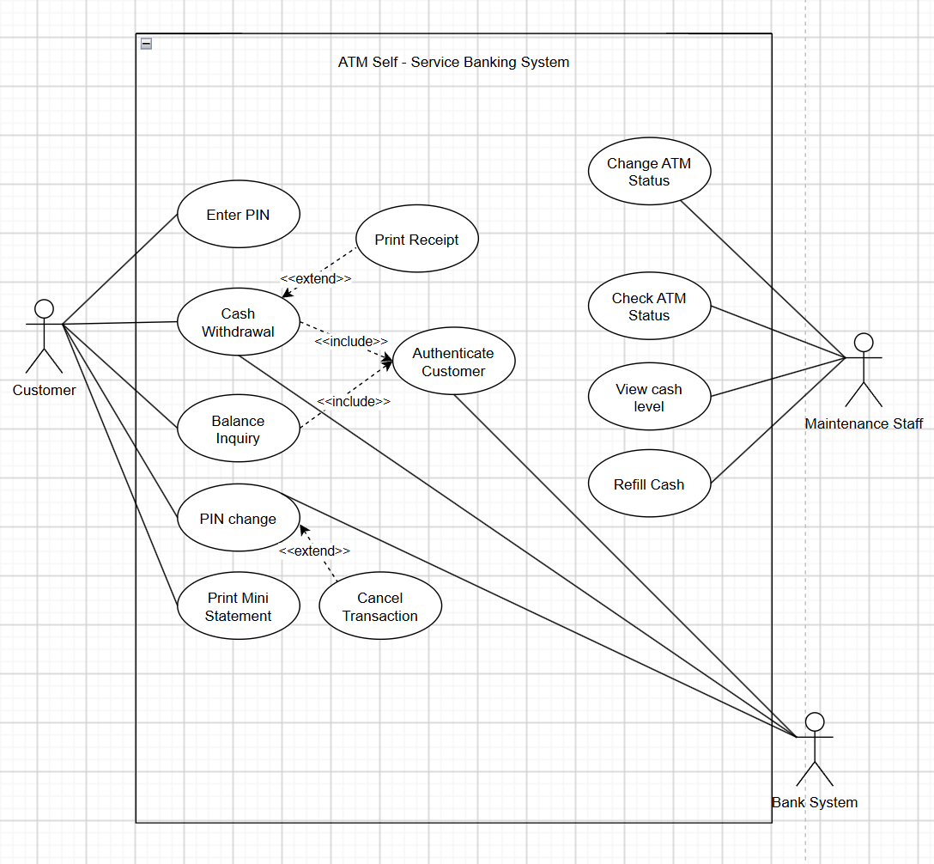

Part C. Activity Diagram
Draw an Activity Diagram for the Cash Withdrawal process.
The activity diagram may assume that the customer has already logged in successfully and selected Cash Withdrawal from the main menu.
The diagram must include:
- Start node and end node
- Actions and decision nodes
- Swimlanes
- Main flow and important exception flows
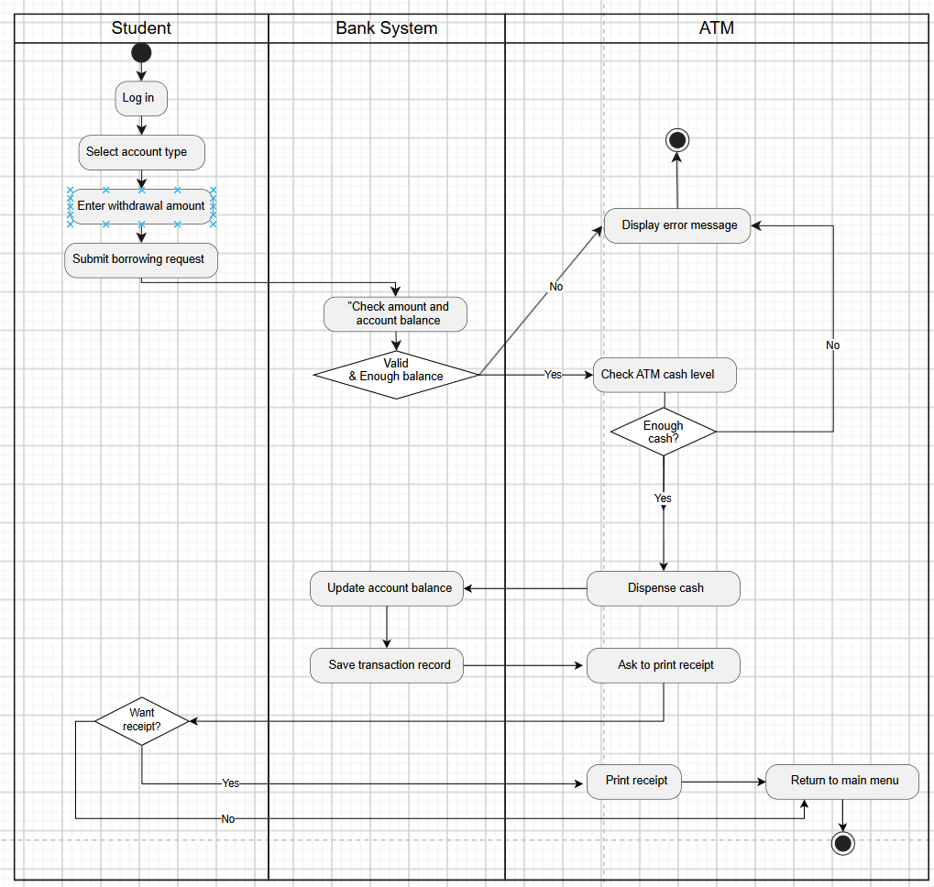

Part D. Class Diagram
Draw one Class Diagram for the ATM system.
The diagram must include:
- At least 7 classes
- Attributes and methods for main classes
- Relationships and multiplicities.
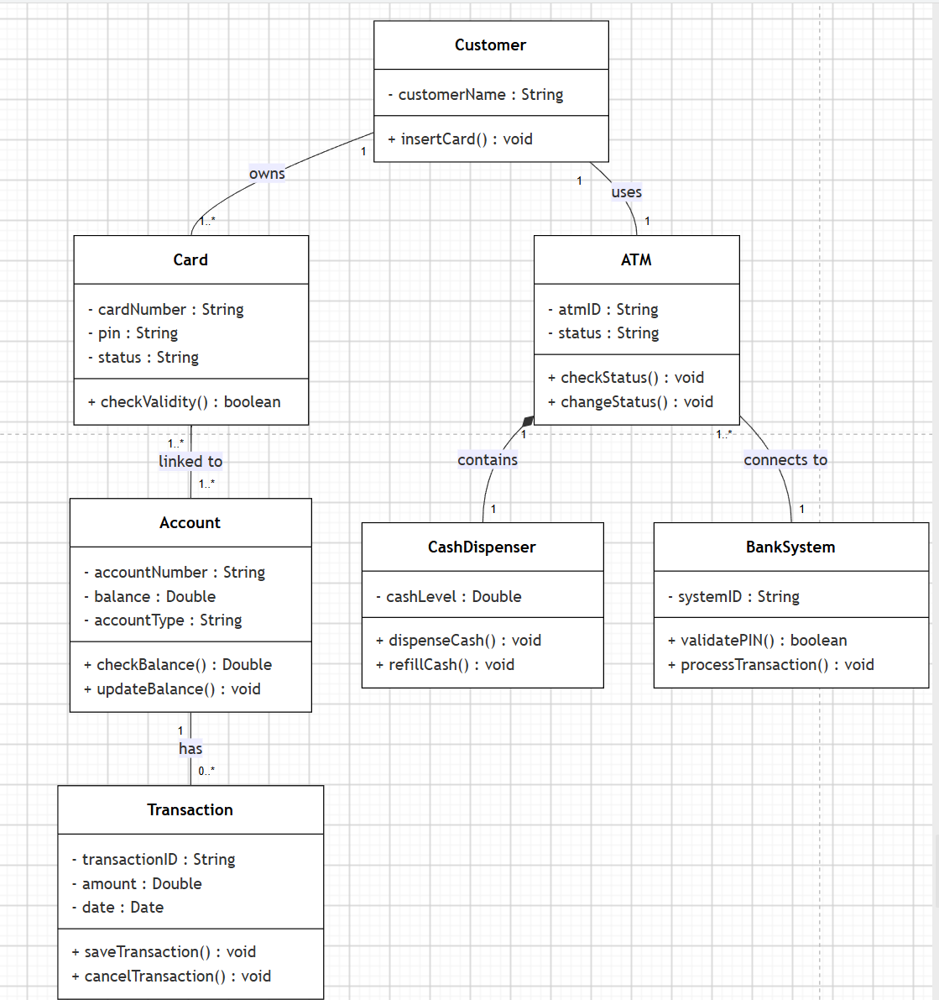

Part E. State Diagram
Draw a State Diagram for the ATM Session.
The diagram should focus on the customer session states, from idle state to authentication, transaction processing, card return or card retention, and session ending.
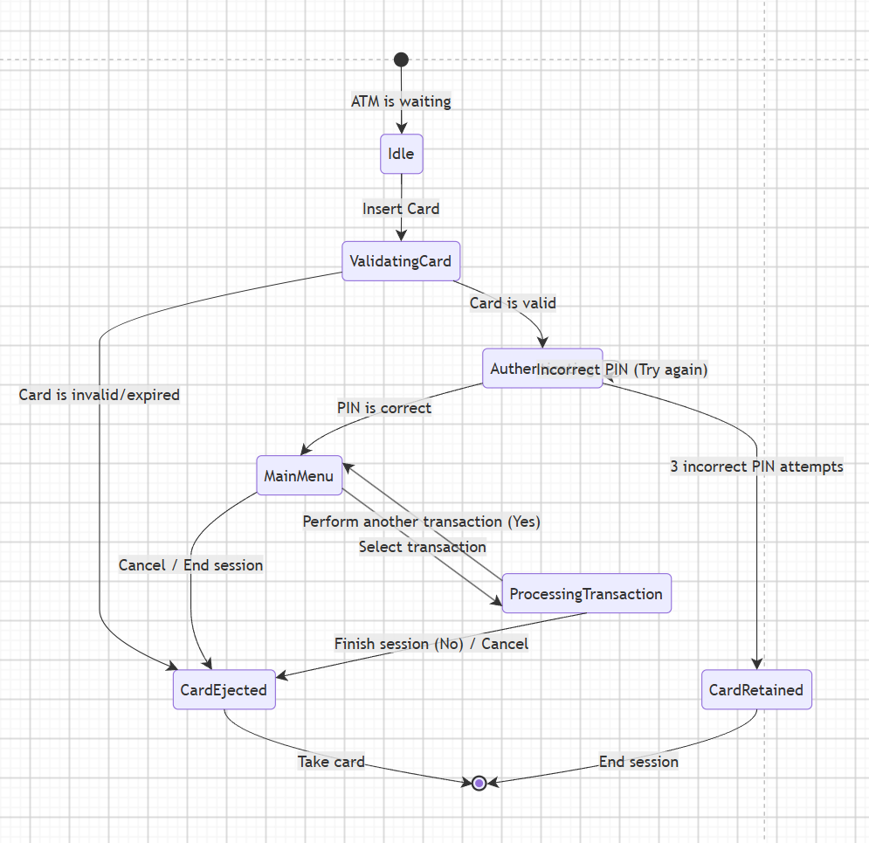

Part F. Sequence Diagram
Draw a Sequence Diagram for Cash Withdrawal after the customer has successfully logged in.
The diagram should focus on selecting cash withdrawal, entering amount, checking balance, checking ATM cash availability, dispensing cash, recording the transaction, optional receipt printing, and returning to the main menu.
The diagram should include:
- Activation bars
- Clear message names
- alt fragment for success/failure cases
- opt fragment for printing receipt

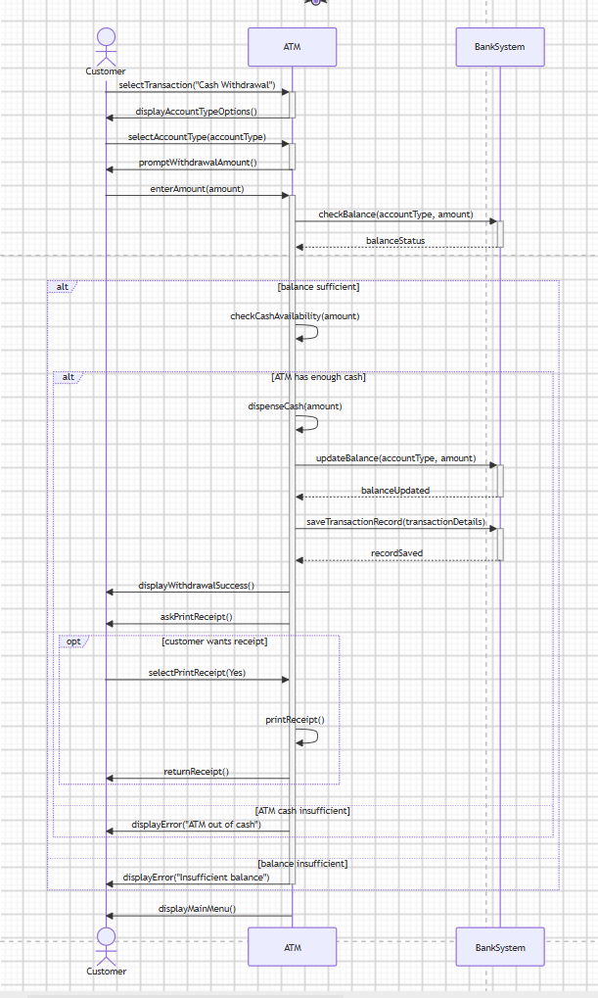

Part G. UI/UX Wireframe Design
Design two ATM screens using draw.io
Form 1. Cash Withdrawal Screen
The wireframe should include:
- Screen title
- Account type selection
- Withdrawal amount input
- Quick amount buttons
- Confirm, Cancel, and Back buttons
- Print receipt option
- Area for validation messages and transaction feedback
- The wireframe must show at least 3 validation or feedback messages, such as:
  - Invalid withdrawal amount
  - Insufficient account balance
  - ATM does not have enough cash
  - Cash dispensed successfully
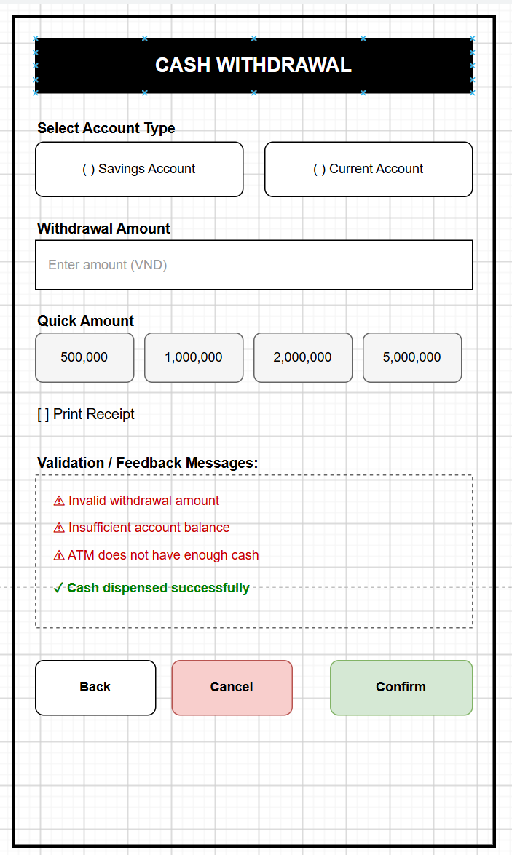
Form 2. PIN Change Screen
The wireframe should include:
- Screen title
- Old PIN input
- New PIN input
- Confirm New PIN input
- Submit button
- Cancel button
- Back to Main Menu button
- Area for validation messages and transaction feedback.
- The wireframe must show at least 3 validation or feedback messages, such as:
  - Old PIN is incorrect
  - New PIN format is invalid
  - Confirm PIN does not match
  - PIN changed successfully
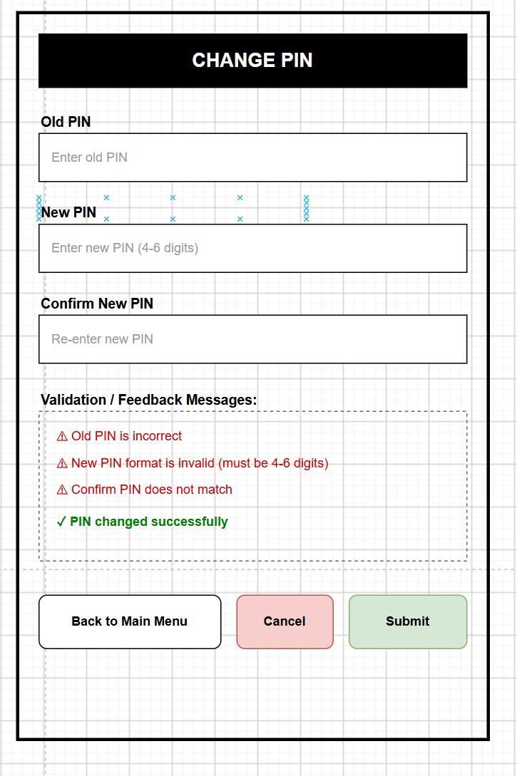

Submission Requirements
- File pdf with format name CSW309_StudentID_StudentName
- The PDF file must include:
  - Functional requirements list
  - Use Case Diagram
  - Activity Diagram
  - Class Diagram
  - State Diagram
  - Sequence Diagram
  - UI/UX Wireframe Design
- All diagrams and wireframes must be created using draw.io.
- All diagrams must be consistent with the same scenario. The names of actors, classes, states, activities, and messages should be used consistently across diagrams.

Notes for Students
Students should focus on correctness and clarity rather than drawing very complex diagrams.
The diagrams should be:
- Easy to read
- Consistent with the scenario
- Properly connected
- Not overloaded with unnecessary details
Students should use meaningful names for actors, use cases, classes, states, activities, and messages.

